EXT. RUN-DOWN FARMHOUSE - NIGHT
Back of beyond. Dripping darkness.
The din of the VW coming our way, then the single headlight
- the glare momentarily illuminates the scruffy yard set in front of the house.
The lads do a double-take when they get a clear view of their eerie lodgings.
EXT. RUN-DOWN FARMHOUSE - NIGHT
On the porch -- TWO ENORMOUS STUFFED BEARS stand guard
at the entrance as if they have been frozen in time. The trash can is riddled with bullet holes.
VANCE and JEFF apprehensively stumble through the open door.
P16 S15 to
P28 S26
This set up is ideal (1)
ANNA and PHILIP'S home Northern FRANCE - FARMHOUSE type with yard or driveway
If possible we would like to film interiors as well, but if not we will have built it somewhere.
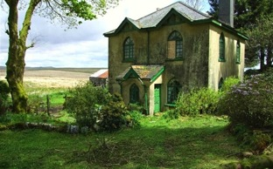

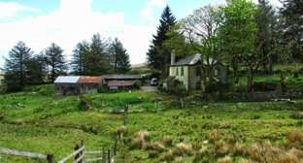

Another examples, again it must have a courtyard
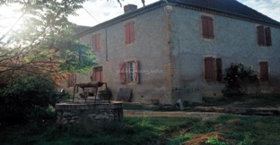

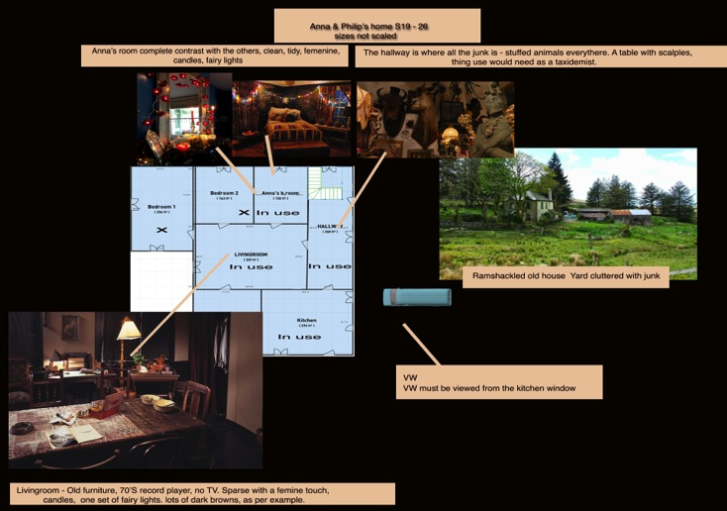

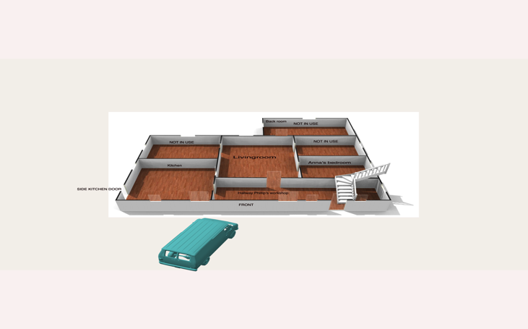

EXAMPLES
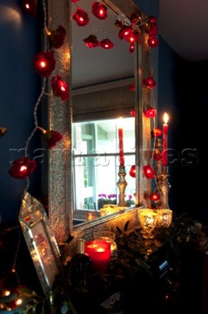
ANNA’S bedroom

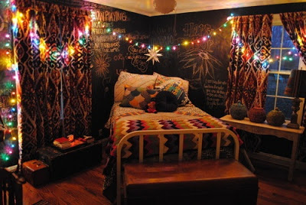
LIVINGROOM
