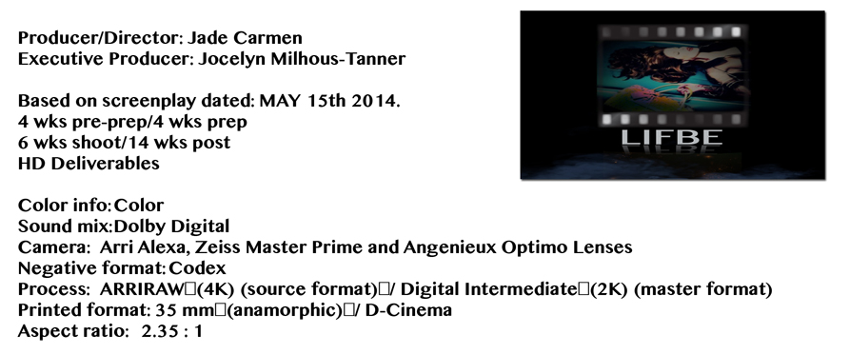
From AERIAL to VFX
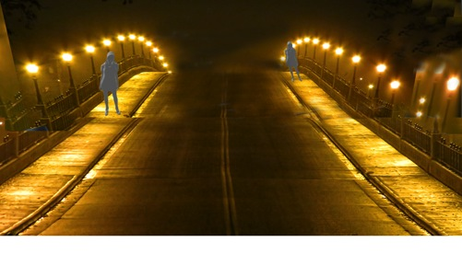
SAME BRIDGE humpback EX WIDE
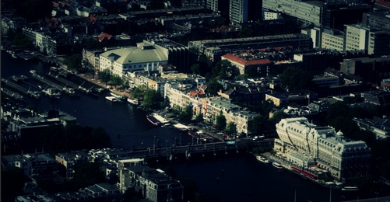

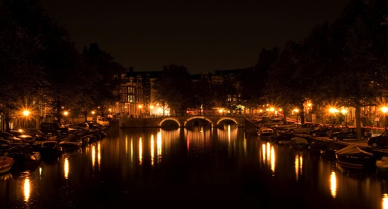

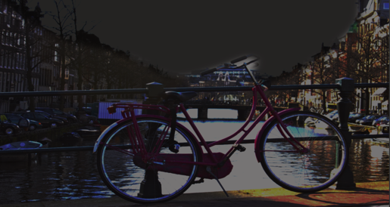
EXT. ROAD - AMSTERDAM SUBURBS - NIGHT
P36 S42
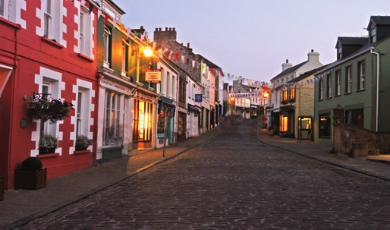
HOGO runs ARABELA over INT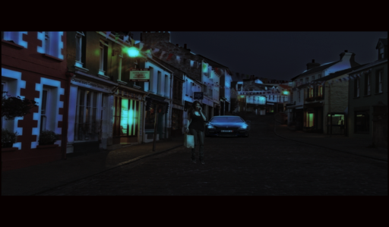

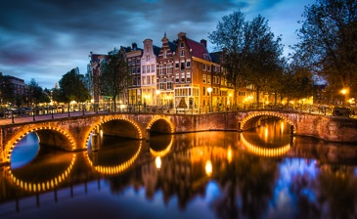
EXT. CANAL DAY
P65 S58
HUNTER speaks to Van OUSTEN and DERK

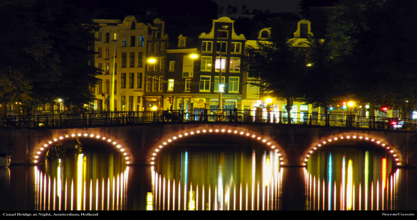

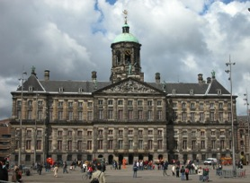
EXT. PARLIAMENT BUILDING - AMSTERDAM CENTRAL -DAY
P73 S90

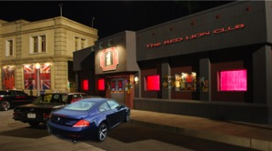
INT. RED LION CLUB - NIGHT (1)
FRONT and BACK
P48
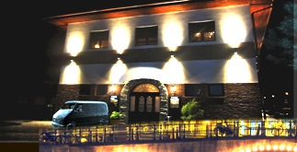
A version of this: equivalent of a Dutch pub/ beirkeller
with a car park at the back or the front
This is non-specific
P74 S92

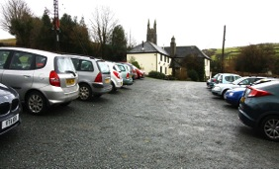

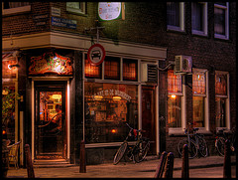

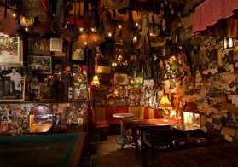
Quirky kind of café. The scene only calls for the characters to be
drinking coffee, not smoking.
As long as it isn't a modern - high tech café
INT. COFFEE SHOP – NIGHT P49 S61 | P49
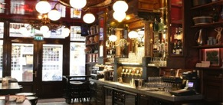

EXT. VALDO HOTEL - NIGHT
INT. VALDO HOTEL – NIGHT
ANY establisher of a small cheap hotel
Safety

WALKING shots through the Red Light District (minimal)

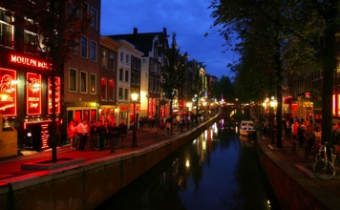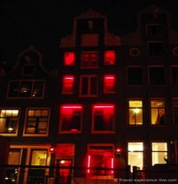
EXT RED LIGHT DISTRICT – NIGHT P51 S62
ANNA and VANCE walking.
They turn into Oudezijds Voorburgwal Straat. ANNA notices the street sign above,
clocks the ‘Red Lion Club,’ opposite.
----------------------------------------------------------------------------------------------------------
EXT RED LIGHT DISTRICT – NIGHT P122 S96
PHILIP chases HUNTER through the streets
TThe only action shots are below

All other shots can be shot anywhere that has the same feel, so not in the RED LIGHT DISTRICT proper.
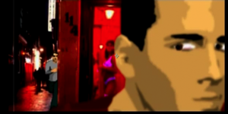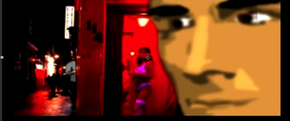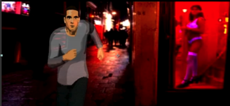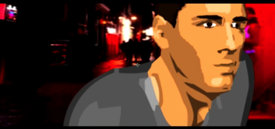
YOUTUBE link to animated storyboard
http://youtu.be/7gs1JKzjJ6I

INT. TAXI - DRIVING – NIGHT P56 S69 |  |  | VARIOUS DRIVING:
 |  |  | TAXI following HUNTER'S CAR
  VARIOUS DRIVING:
  TAXI following HUNTER’S CAR – eventually pulls up
  outside a block of expensive flats on the outskirts of town.
  BELOW
  EXT. ALLYEWAY - NIGHT outside block of flats P57 S72
  The action is in behind the building just need it as foreground
  just need it as foreground.
 |  | X | eventually pulls up a posh block of flats
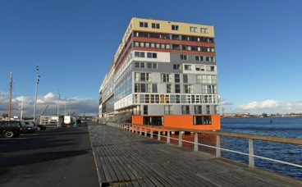  New Silodam apartments Amsterdam  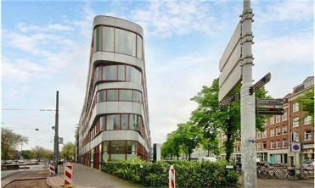  Mauritskade Amsterdam |  |  | on the outskirts of town.
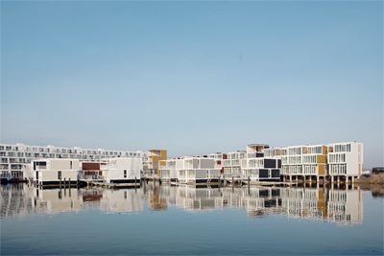
Steigereiland

EXT. CANAL STREET – DAY S61 P77
ANNA and JEFF are strolling on the way to the café

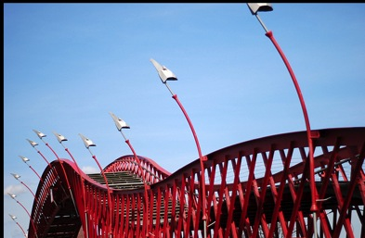
--------------------------------------------------------------------------
EXT CANAL BOAT – DAY P74 S89
INT. CANAL BOAT – DAY P74 S91

ONE docked away from the main highway

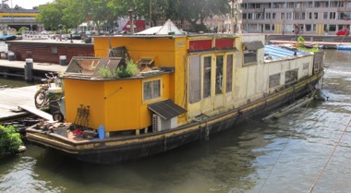
ANNA visits KATRIEN

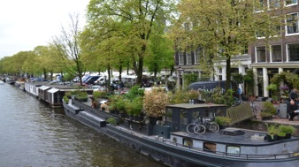

EXT. CAFÉ – DAY P78 S95
JEFF, VANCE and MEEGEREEN talks to JEFF and VANCE
ANY outside café will do.
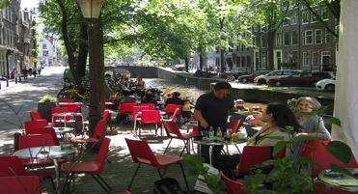

EXT. CAFÉ – DAY P83 S97
KURT and PHILIP sit in a café across from their hotel in the Amsterdam suburbs
An outside café across from a cheap hotel
The VW is parked outside the hotel in KURT and PHILIP'S' view. They are at the table.
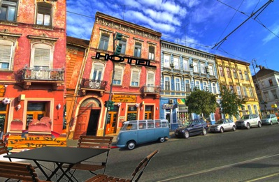
----------------------------------------------------------
EXT ALLEYWAY – NIGHT P96 S123 ALLEWAYS /ARCHES
PHILIP+ HUNTER Chase scene on foot.
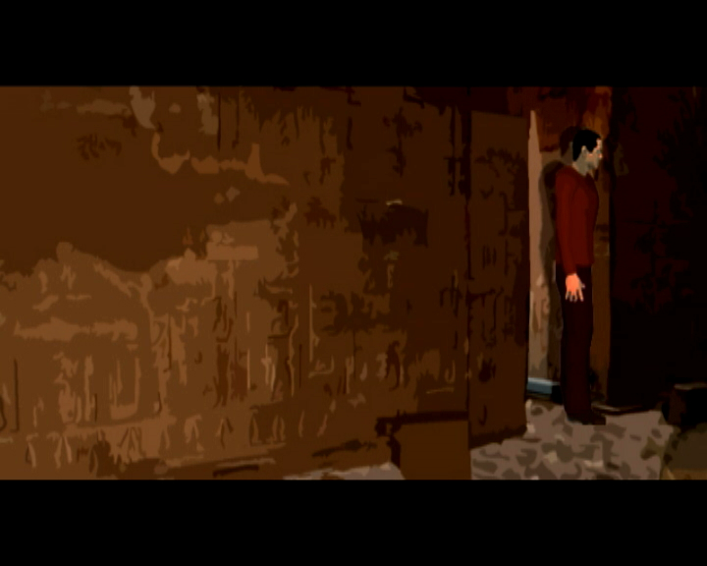

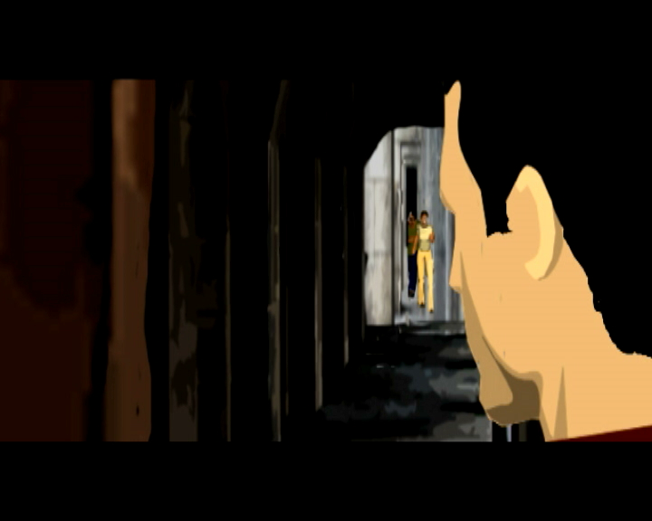

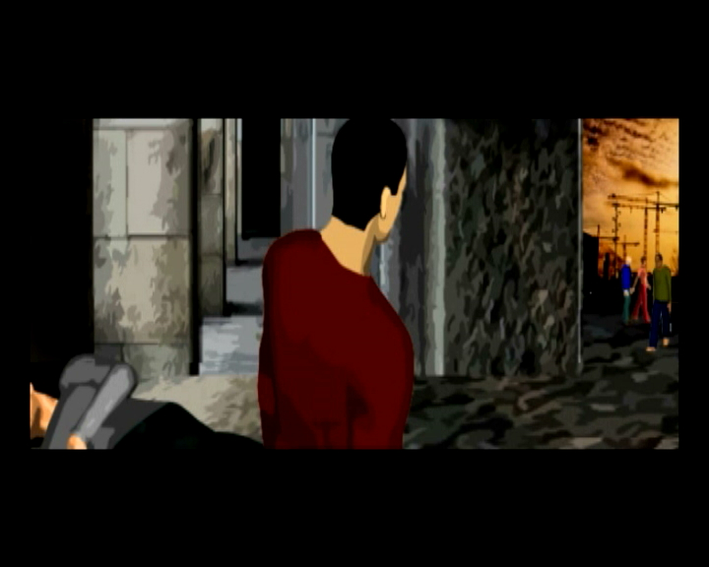

EXT. COURTYARD – NIGHT P97 S127
This could be a building site. Anywhere out of the way of the general public
The script explains it.

Or

CAR PARK AMSTERDAM
ANYTHING ARCHITECTUALLY UNUSUAL
S126 P97
THIS IS SET IN THE SCRIPT AS A COURTYARD, BUT IT MIGHT BE HARD
TO FIND THE LOCATION AS IT IS A DIFFICULT SCENE
MIGHT BE MORE CONTROLLED IN AN UNDERGROUND CAR PARK
NIGHTMARE FOR SOUND, BUT HE WE FIND AN UNUSUAL
CAR PARK VISUALLY IT WILL WORK
ALSO GIVE US A RAIN COVER DAY
THIS IS A NIGHT SHOOT SO COULD WORK OUT TO OUR ADVANTAGE.
EXT. COURTYARD - NIGHT
HUNTER catches his breath, drags himself through the arch into the courtyard.
The POLICE INTERCEPTOR follows.
HUNTER stops in his tracks -- trapped -- it’s a dead end.
DS DERK and DS VAN OUSTEN -- out of the POLICE INTERCEPTOR --
both armed, wearing vests -- flashlights -- blinding HUNTER.

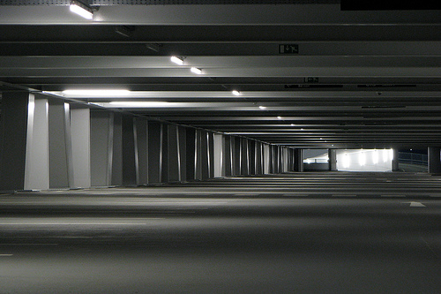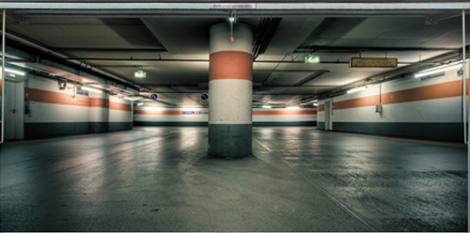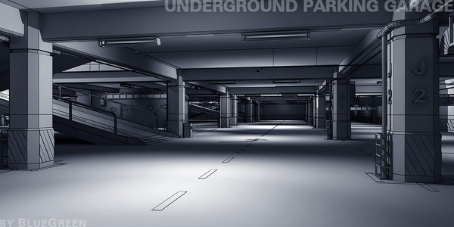

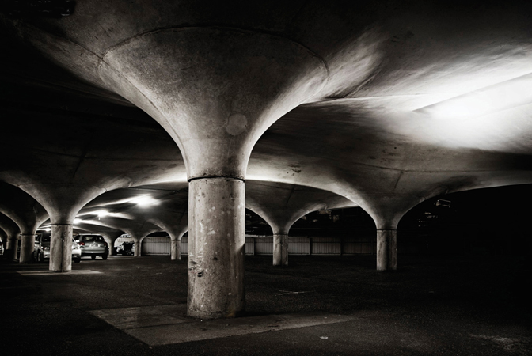

Or Below. Some kind of derelict ground
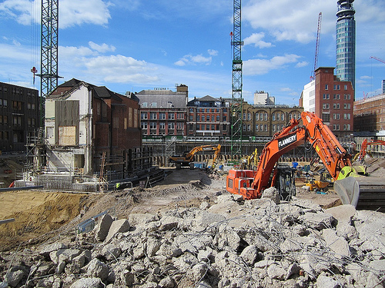

EXT. AMSTERDAM COURT BUILDING – DAY P100 S129
Whichever court would deal with serious crimes.
EXT ONLY
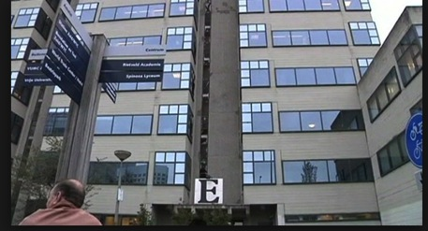
---------------------------------------------------------------------------------------------------
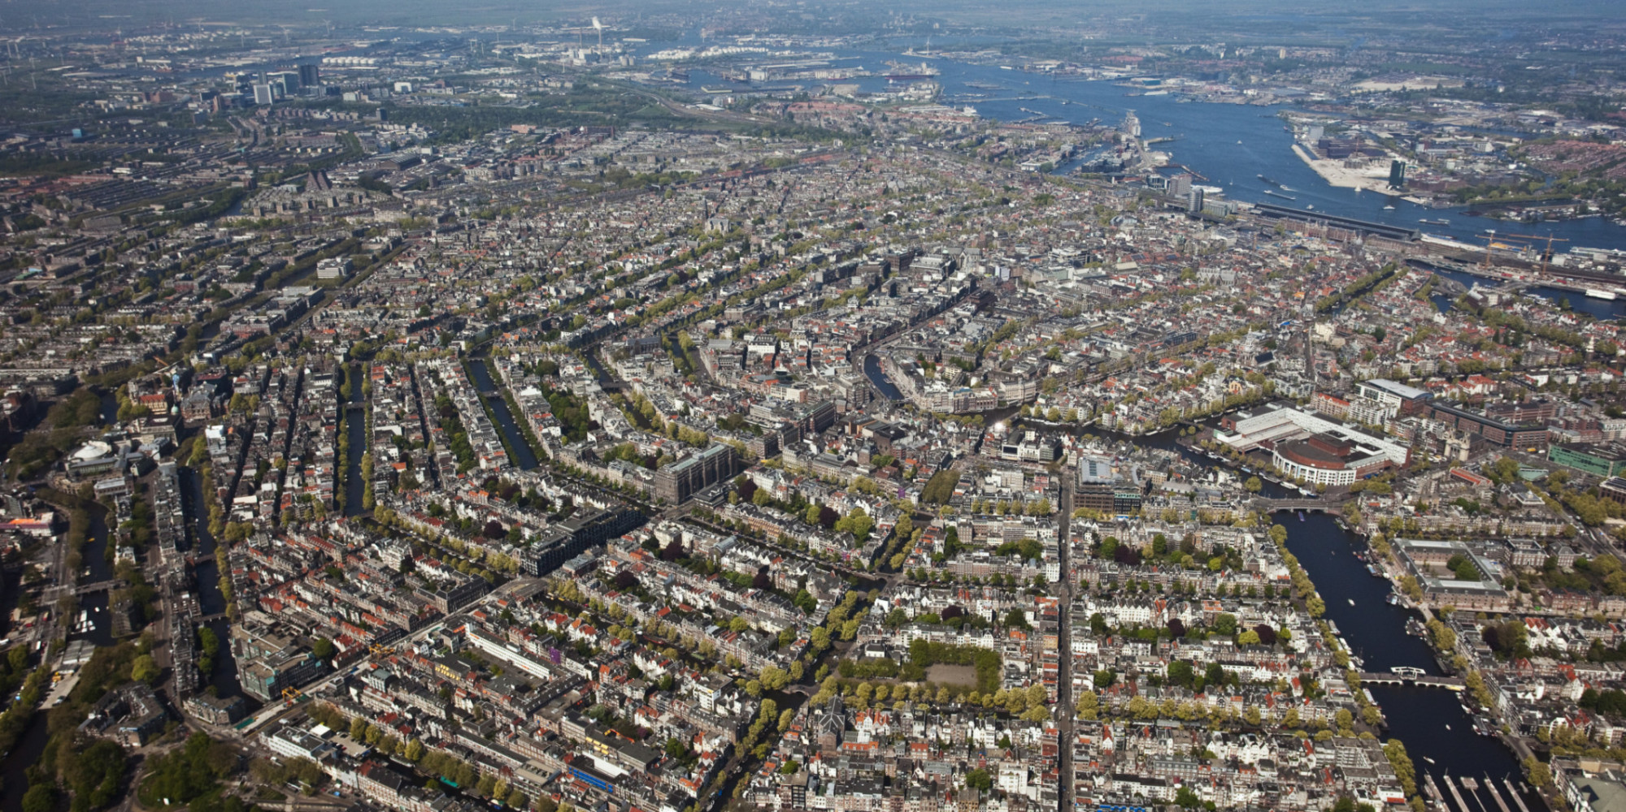
2 X EX AERIALS
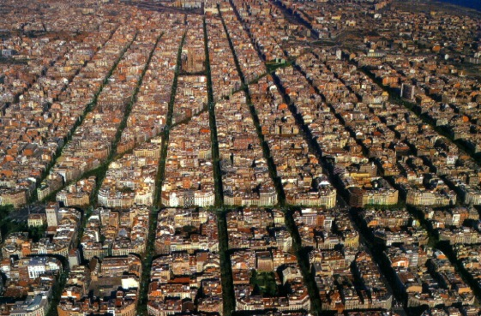

INTERNET CAFE
