EXT RED LION CLUB
HUGO 6 SERIES BMW OUT FRONT
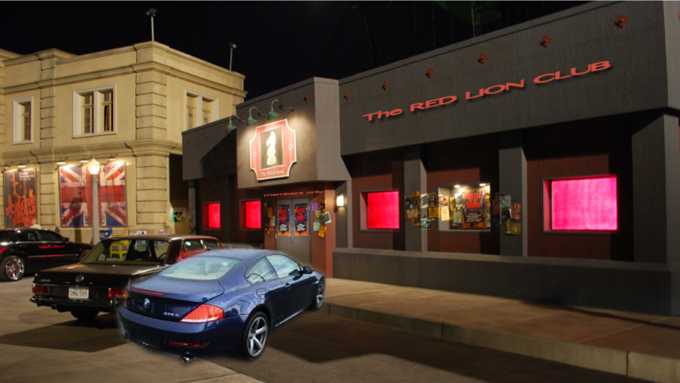

MOCK BACK EXIT SHOULD BE NEXT TO THE CANAL
