INT RED LION CLUB
Upmarket pole dancing club. Not a strip club.
EXAMPLES
Not a huge venue.
Somewhere they have great lighting system preferred,
but no essential
NEED it for 1 day 2 at the most

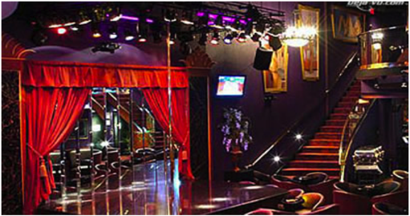

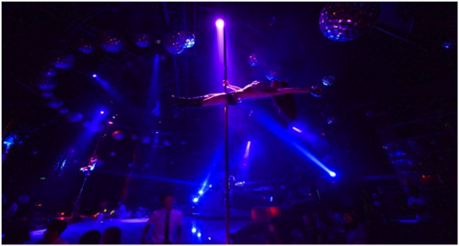
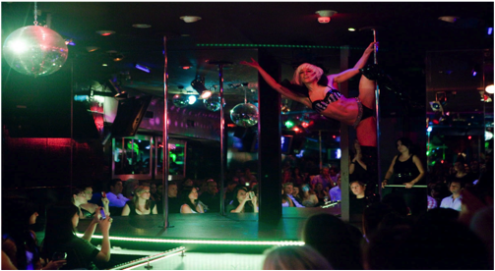
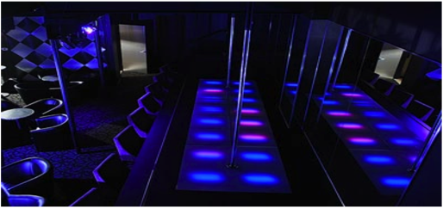
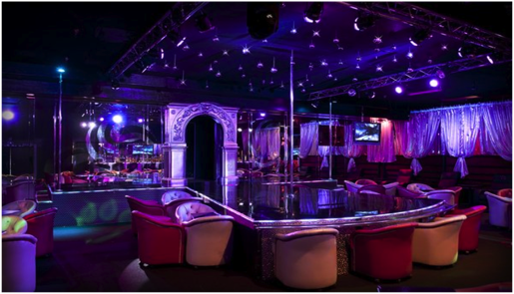
 |  |  | 4 |  | 5
