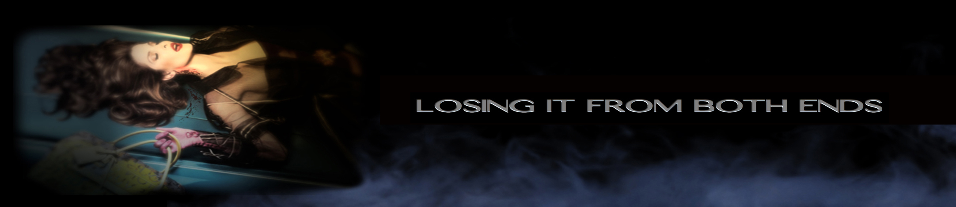
- #1 INTRO SEQ MUSIC and TITLES 2 min 40 sec WIDE STATIC CAMERA VW FROM CAMERA LEFT
- #2 CLEAN FRAME
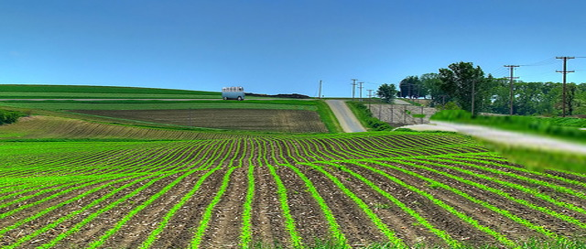
- #3 STATIC
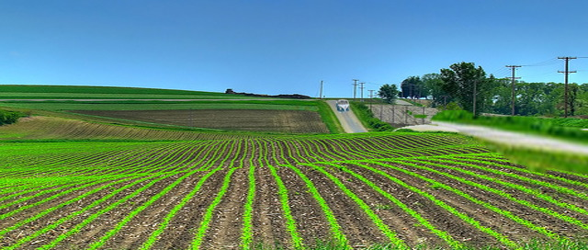
- #4 STATIC
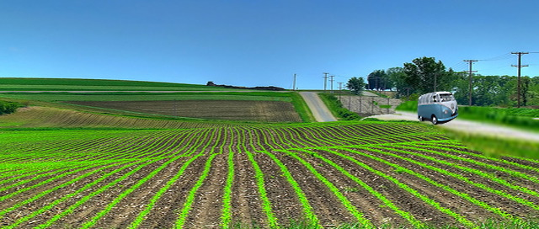
- #5
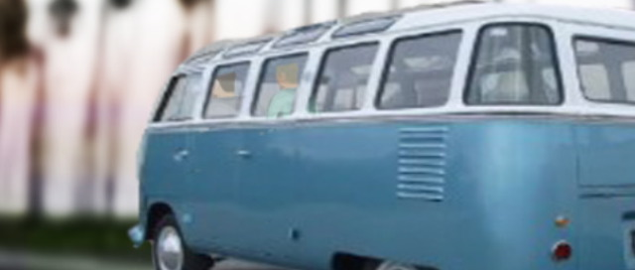
- #6 STATIC TITLES
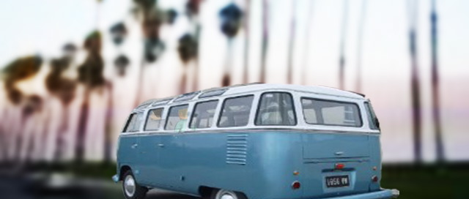
- #7 STATIC DRIVE BY TITLES
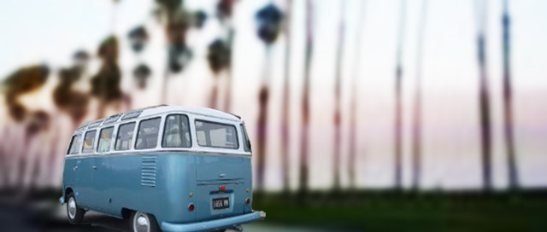
- #8 TITLES
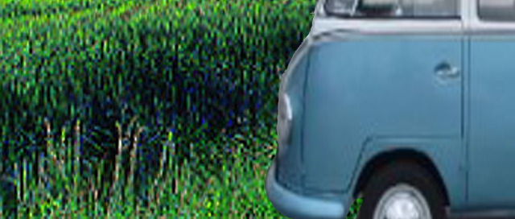
- #9 STATIC R to L
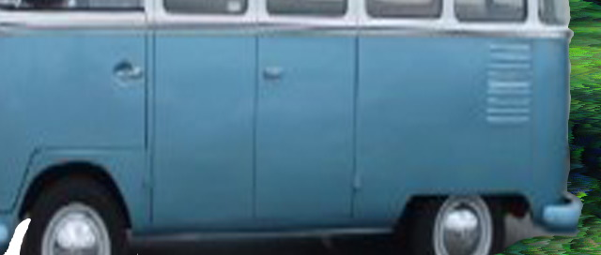
- #10

- #11 TITLES
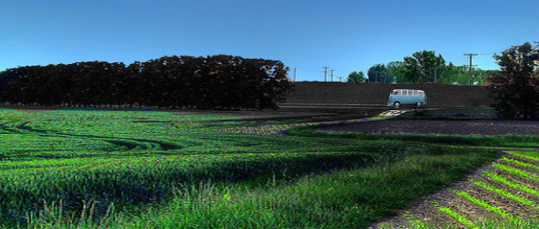
- #12 STATIC LONG LENS R to L
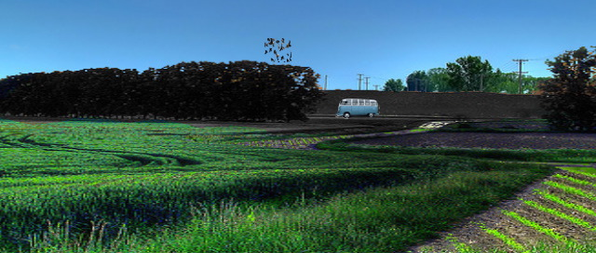
- #13
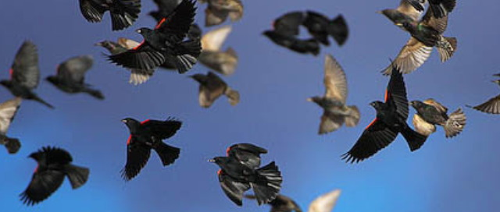
- #14 INSERT R to L TITLES
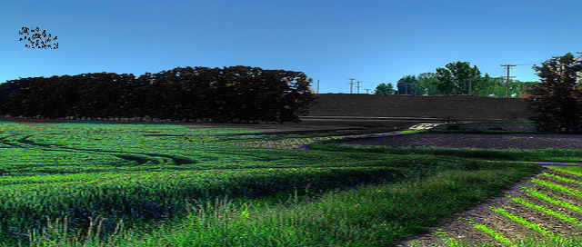
- #15 WIDE R to L+L to CAMERA
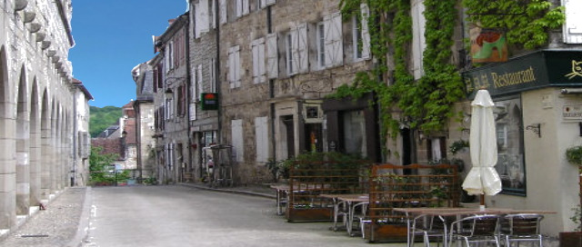
- #16 STATIC
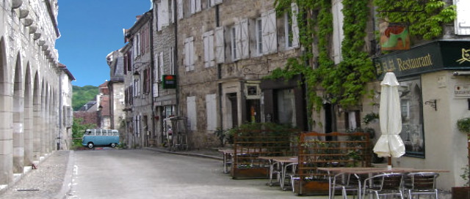
- #17 STATIC R to L
- #18 TITLES
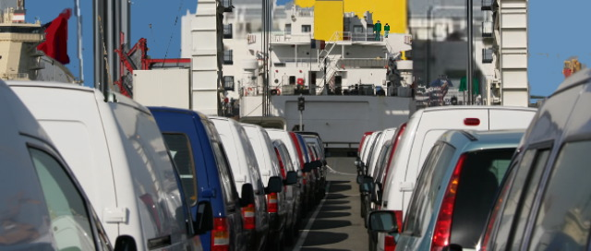
- #19 EXT. FERRY DOCKS - CALAIS – DAY

- The Dover to Calais ferry has just docked. A cacophony of car engines fire into action. ZOOM 1 LONG LENS
- ZOOM +
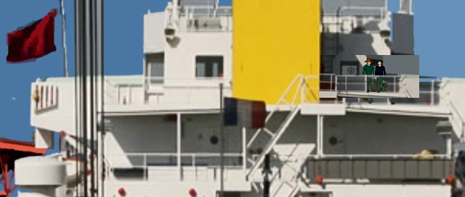
- #20 VANCE and JEFF, two handsome hipsters in their early twenties stand on deck, ZOOM 2
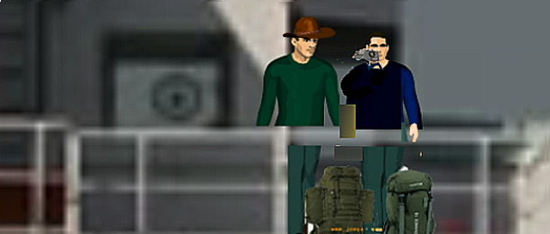
- #21
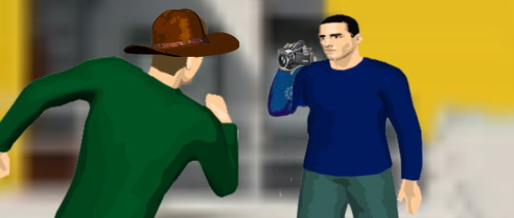
- #22 REPO Note: NO DIALOUGE ON BOAT BECAUSE OF SOUND ISSUES - FOLEY SOUND
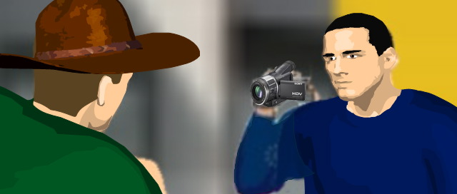
- # 23 VANCE mucking about.
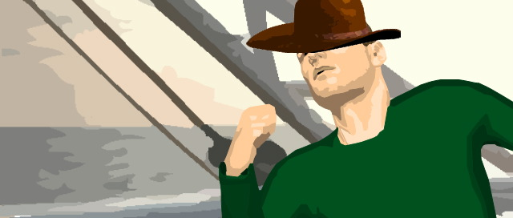
- #24 Wind blows VANCE hat off
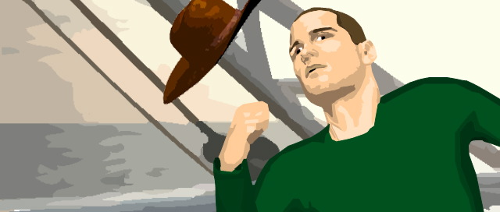
- #25 SOUND : The HUGE METAL GANGWAY slams down on the jetty.
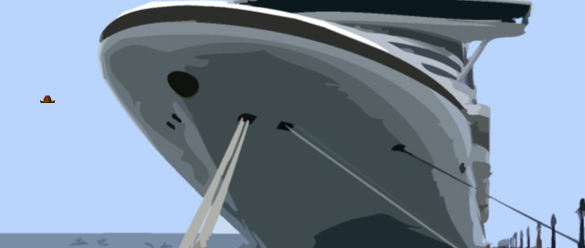
- #26 WIDE ESTABLISHER
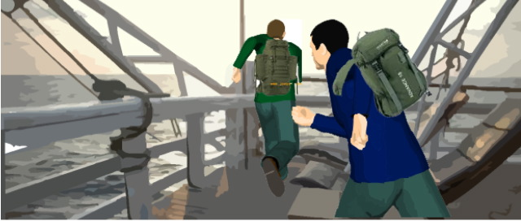
- #27 VANCE and JEFF R to L
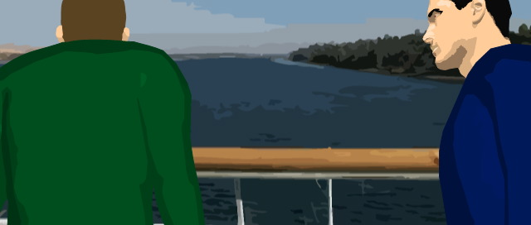
- # 28 VANCE and JEFF look over the edge.
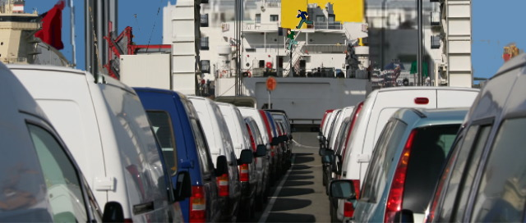
- #29 VANCE and JEFF scuttle like greyhounds released from days of confinement. Ferrymen herd the vehicles down the ramp.
- MUSIC 1 FADE
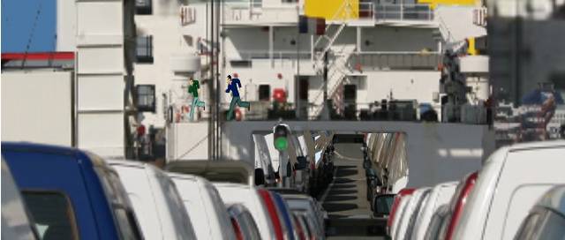
- #30 TITLES END

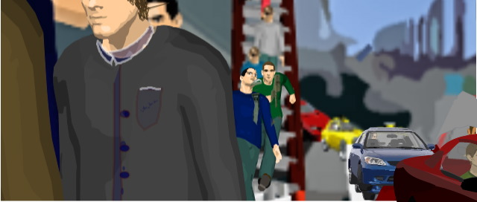
- #31
- JEFF and VANCE push through the swarm of foot passengers....their heavy rucksacks hamper them as they head for the exit stairway. FOLEY SOUND MUSIC (1)FADES>>>>

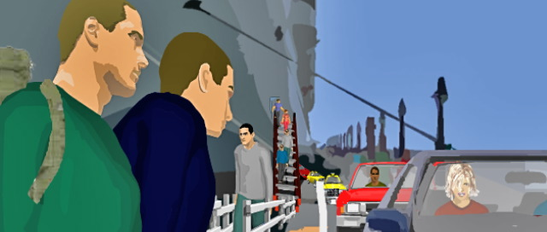
- #32 They stick out their thumbs and smile. MUSIC (2) FADE IN Sound coming from interior of car (muffled)
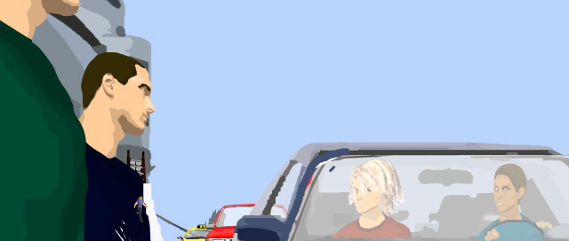
- #33 TWO ATTRACTIVE YOUNG GIRLS wave at VANCE and JEFF as they pass in their French registered CAR. VANCE takes a cardboard sign from his rucksack, thrusts it at the passing vehicles. It reads: "Paris please."
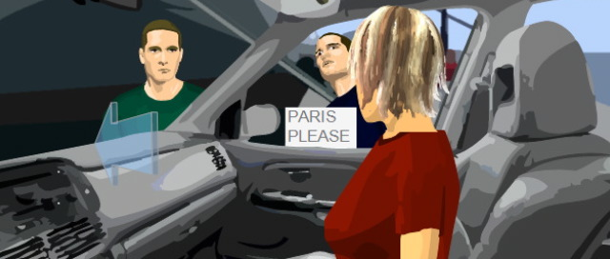
- #34 The GIRLS smile, but don't stop. The GIRL looks back at the lads

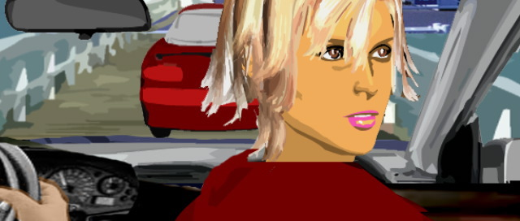
- # 35 JEFF waves back excitedly, gesturing them to stop, the CAR speeds off.

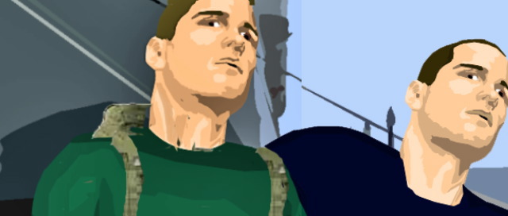
- #36 JEFF>French girls have certainly got something.
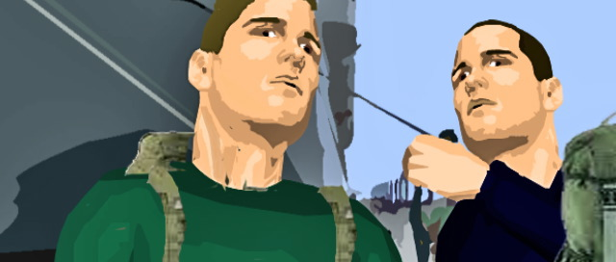
- #37 VANCE>They have attitude. I'll give you that. They know they're beautiful, so they try and get away with murder. I've had experience. Watch out.

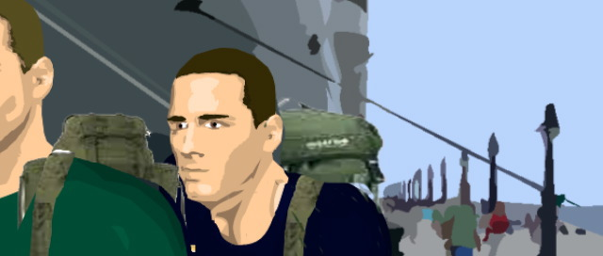
- #38 LEAVE FRAME
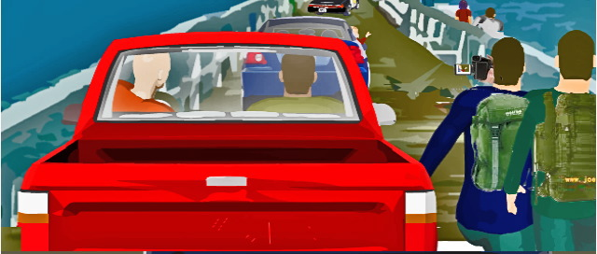
- #39 VANCE and JEFF run down the gangway chasing the CAR.

- JEFF films with the DVcamera as he heads down the gangway.
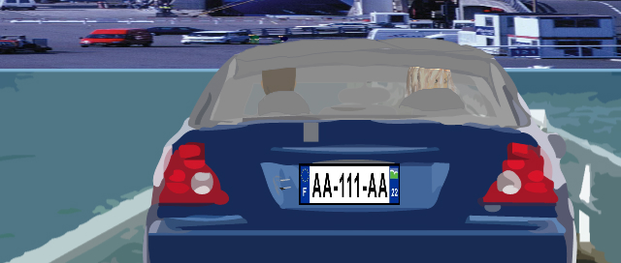
- #40 The CAR continues. The GIRL looks back.
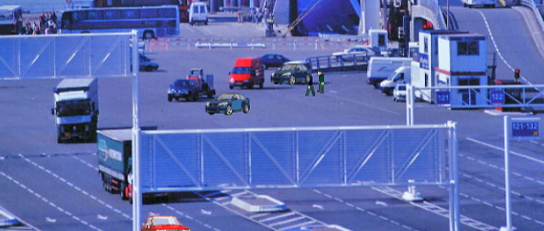
- #41 WIDE. JEFF and VANCE have no luck with a ride.
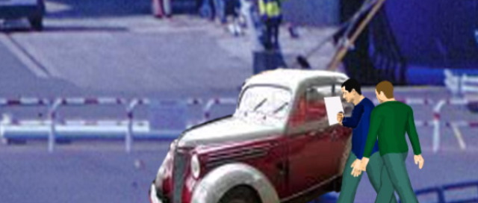
- #42 VANCE takes over, JEFF sits on his rucksack.
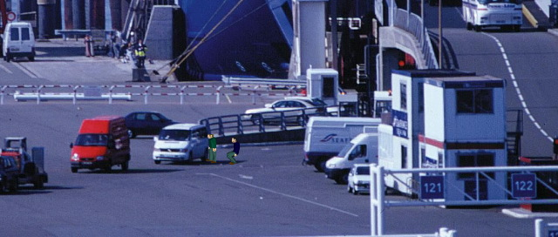
- #43
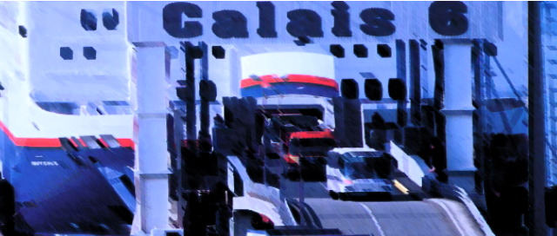
- #44The last cars rumble down the ramp.
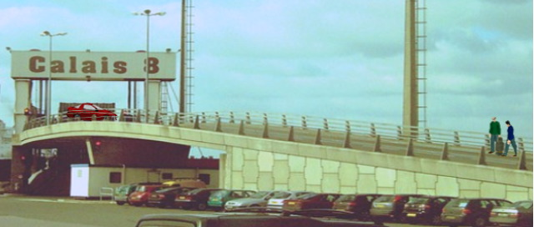
- #45 EXT. FERRY - EXIT GATE – DAY JEFF and VANCE look desperate.

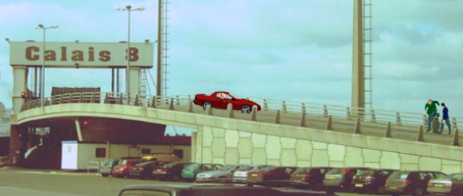
- #46 - VANCE hands the sign to JEFF and sticks out his thumb at the last CAR. He miles at the FEMALE DRIVER, she smiles back, but doesn't stop. They watch the last remaining CARS drive onto the motorway slip road. DIALOUGE starts here.
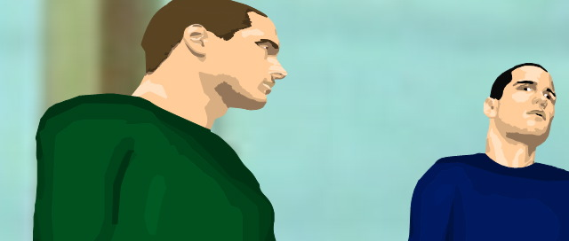
- #47 4/8th p2x SHOT and SINGLES - Dialogue:
- I thought you said this would be easy?.....
- VANCE
- I didn't.
- JEFF
- You did!
- VANCE
- I did not!
- JEFF
- You did!
- VANCE
- I said that Sophie could hitch from London to Paris in a day.
- JEFF
- I think there’s a difference between a gorgeous twenty-three-
- year old French sex-kitten and two hairy blokes.
- VANCE
- (slings his rucksack)
- Come on I bet you ten pounds we’re cruising along in a nice car in the next half hour.

CAMERA LEFT

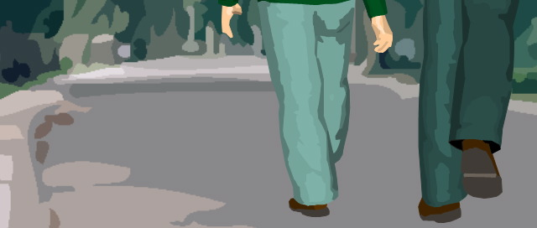
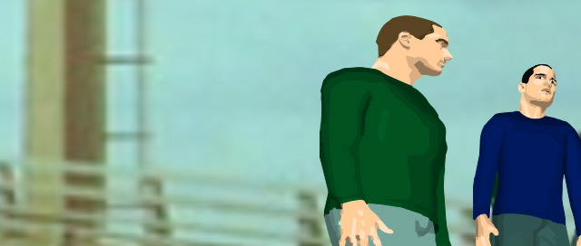
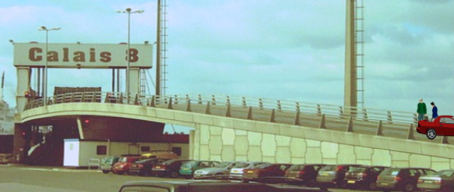
- #48 DISSOLVE TRACKING with them, then let them leaves frames.

- EXT. ROAD CALIAS - day
- JEFF and VANCE trudging along the road.
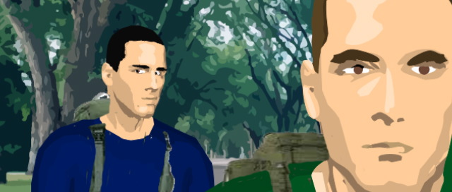

- EXT. ROAD - HOURS LATER
- ROAD SIGN: ‘A26 PARIS 229Km.’
- The summer sun melts behind the hilltops.
- A scourge of mosquitoes.
- VANCE traipses in front -- thumb in the air.
- JEFF -- swiping -- trailing the sign behind him.
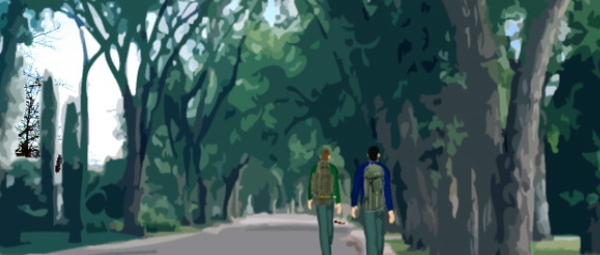
- #49 WIDE REVERS
- #50 CU
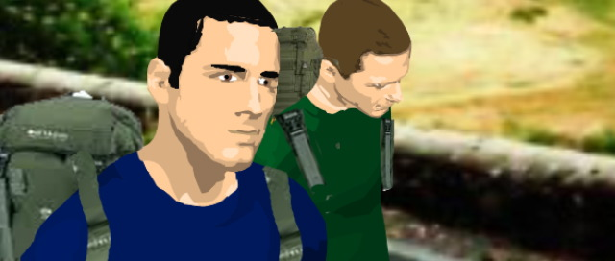
- #51 2 SHOT MID
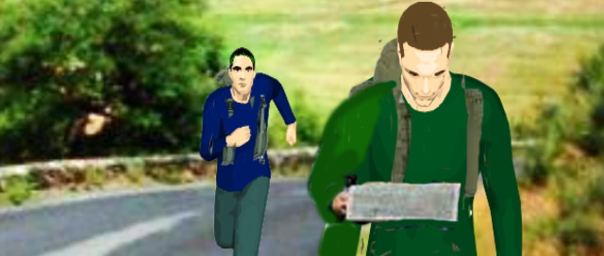
- #52
- VANCE halts -- delves into his pocket -- brings out a tourist map.
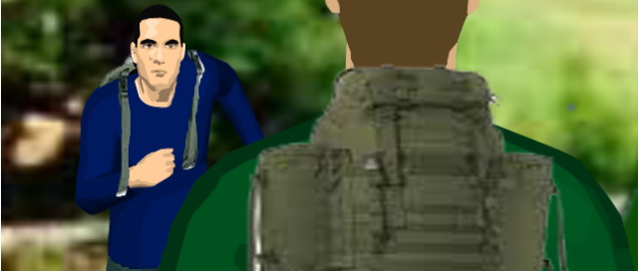
- #53
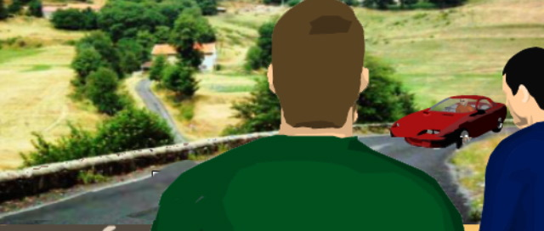
- #54
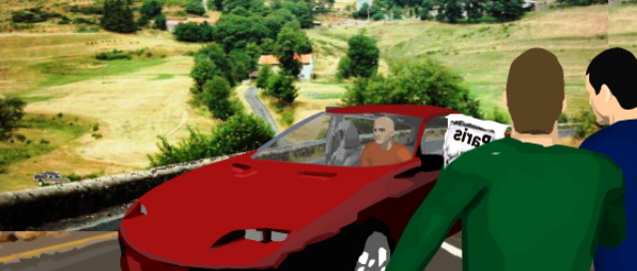
- #55
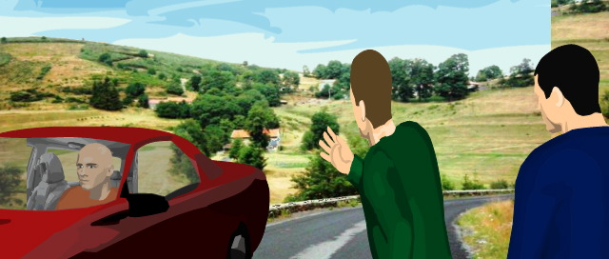
- #56
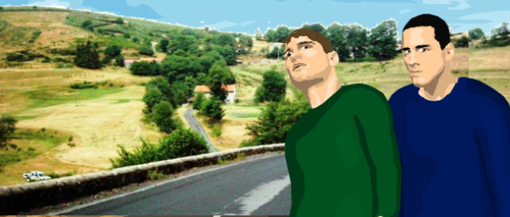
- #57
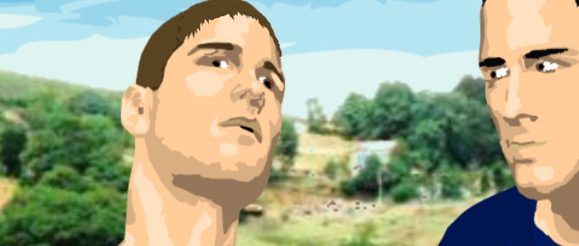
- #58

- 

 