POLICE CHASE SEQUENCE 7
EXT. CANAL STREET – NIGHT S116 P95
The POLICE VEHICLES -- some distance away, hammer down the street in pursuit.
HUNTER hauls the TRANSIT VAN straight through a give way junction.
CROSS-TRAFFIC brake -- just in time -- holding up the POLICE VEHICLES now.
TRANSIT VAN – HUGO DRIVING ANNA, PHILIP, KURT in the back.

STATIC CAMERA
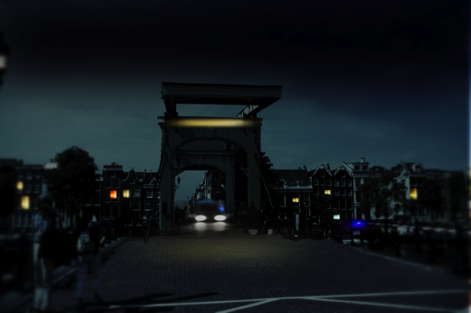

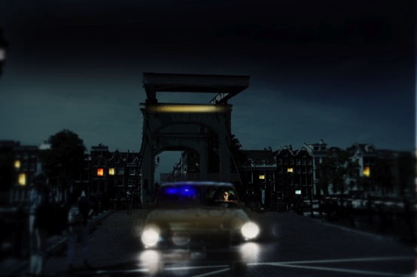
The TRANSIT could clip the back end of the white car – Heads straight towards camera.
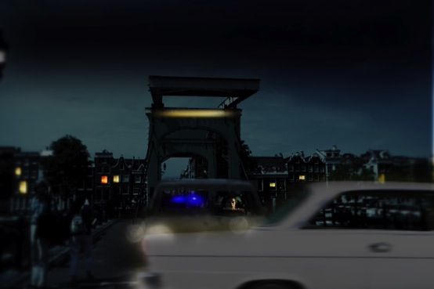

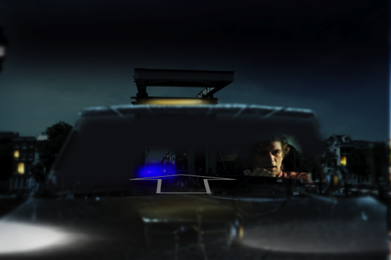
POSSIBLE transition up over the car, tilt to a high wide angle. I don’t have that plate shot so I can’t storyboard it. But can explain.